| Mini Project Report |
| --- |
| **Green Flash** |
| Author:  **Saleh Mohammed Alanazi**  **Anas Ahmed Alwohaib**  **Khuzama Khaled Alsnan**  **Alyaa Ali Bajaber** |
|  |
| Supervisor: **Hani Elshafey** |

1. YOLO.ipynb

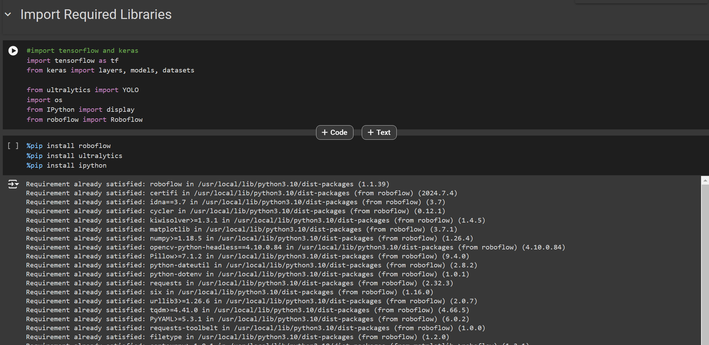

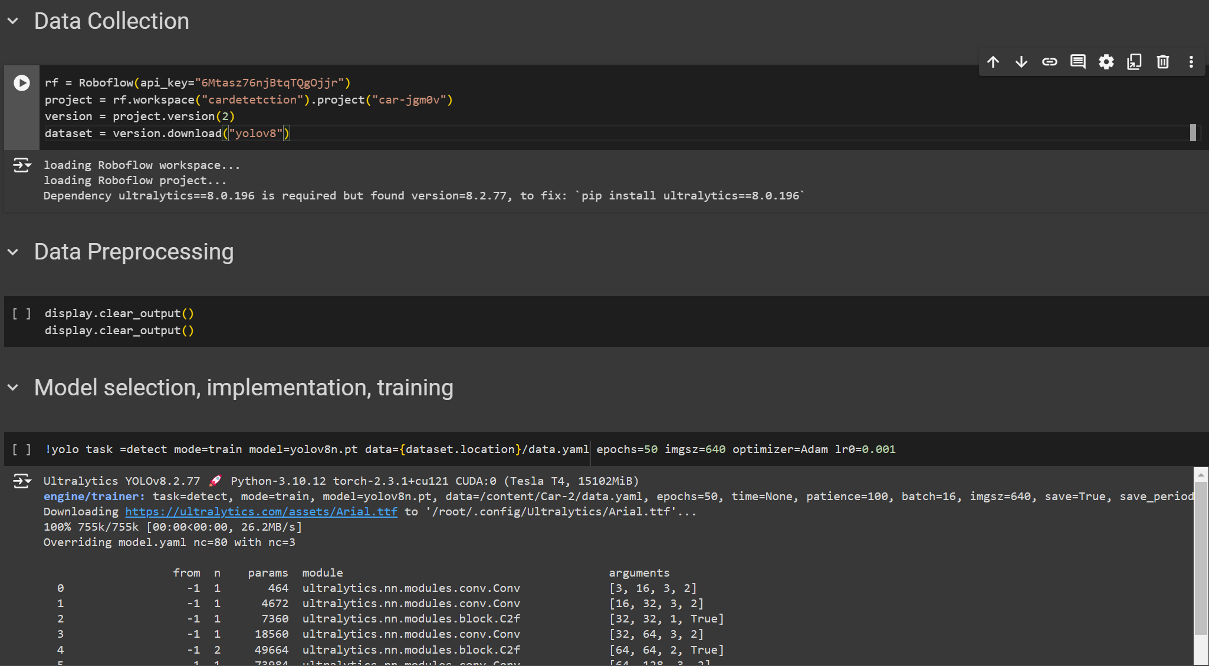

1. CarCounterDetection.ipynb

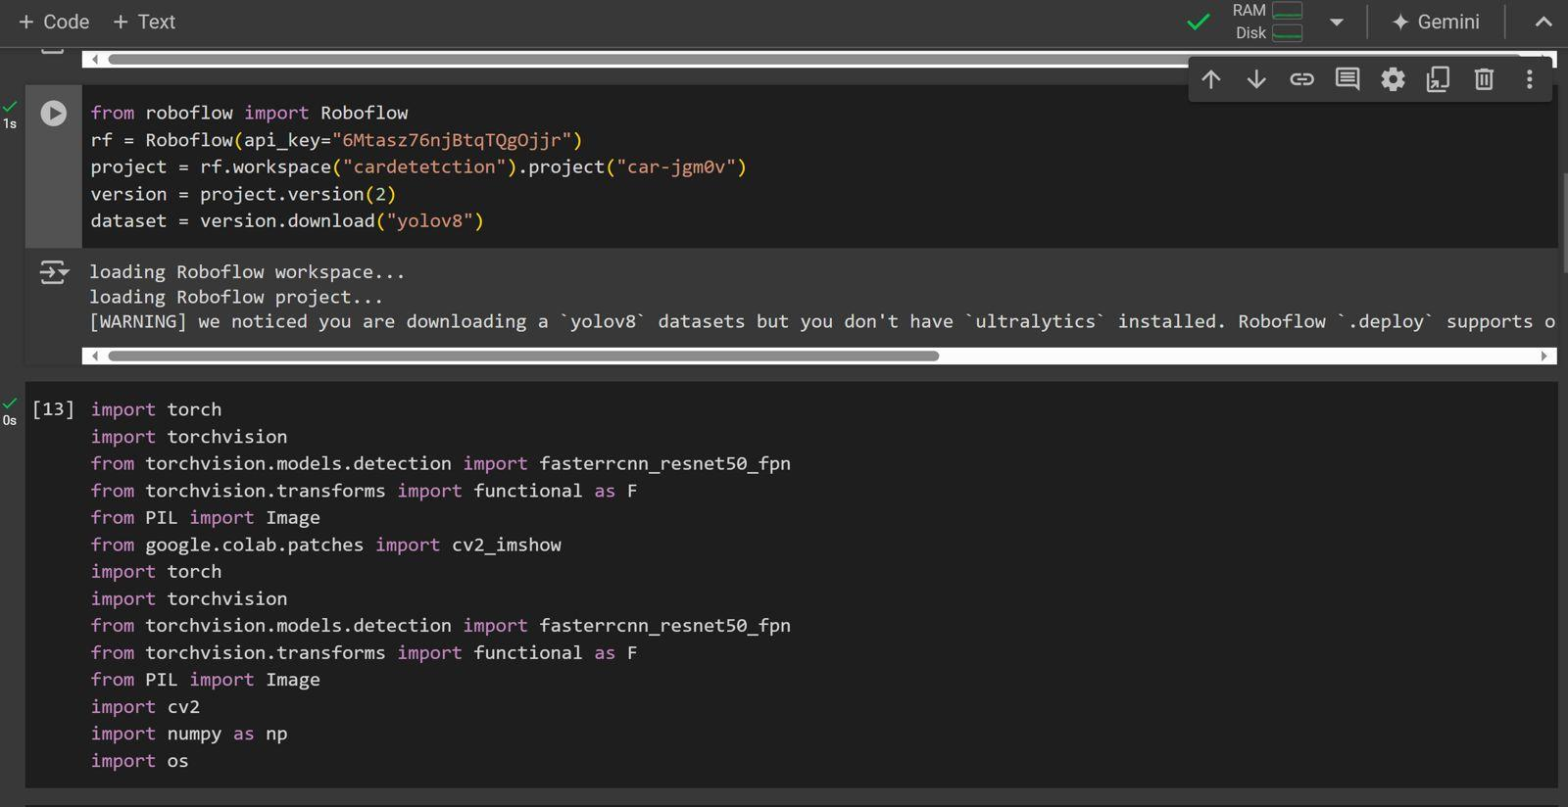

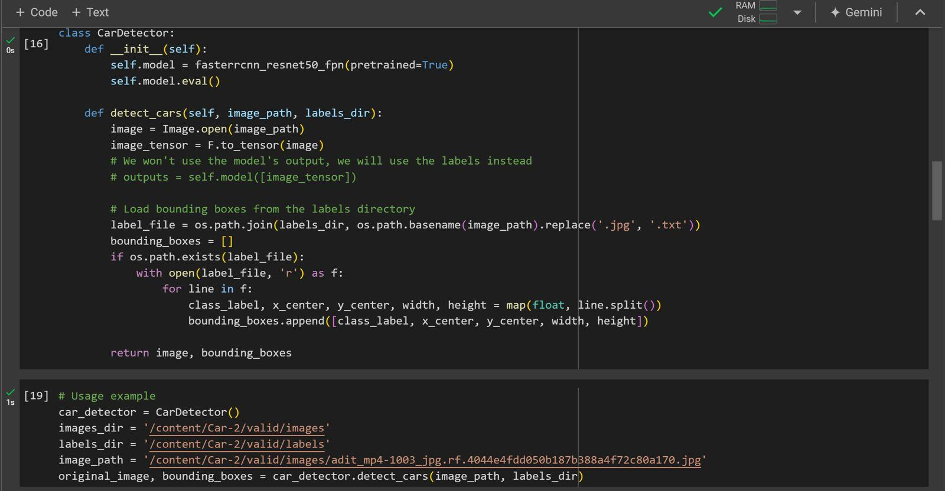

using faster RCNN

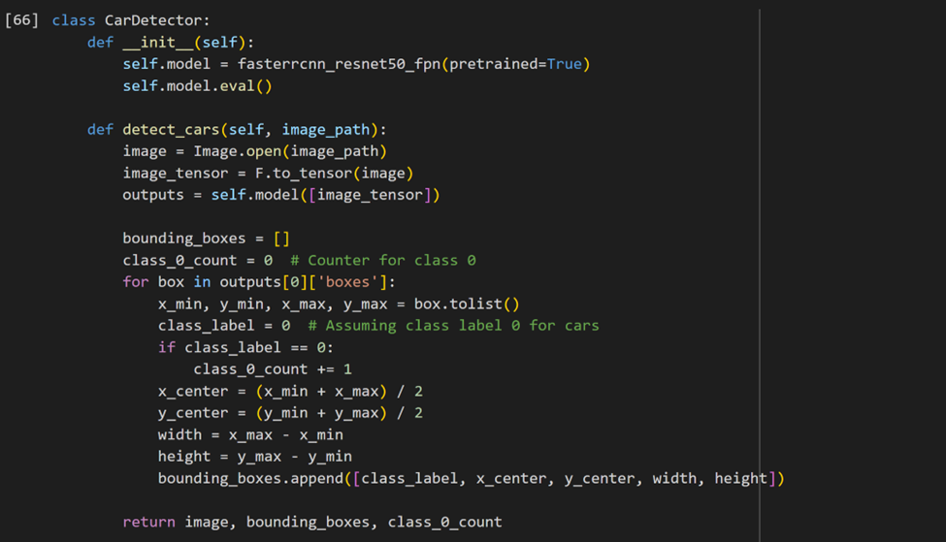

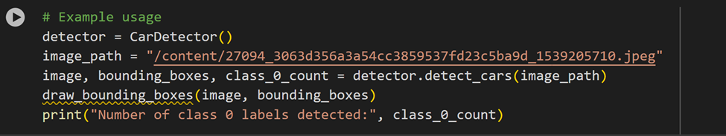

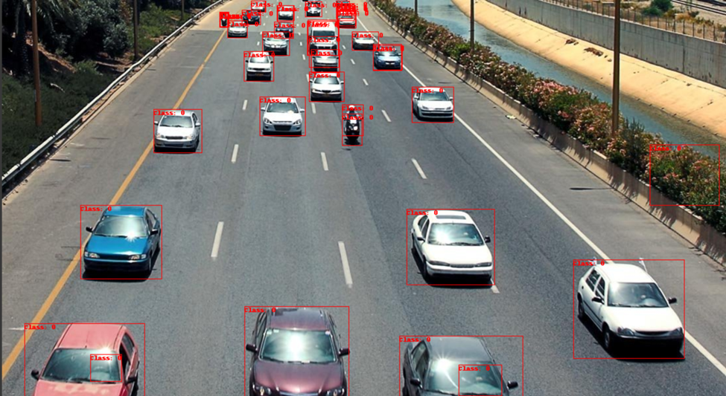



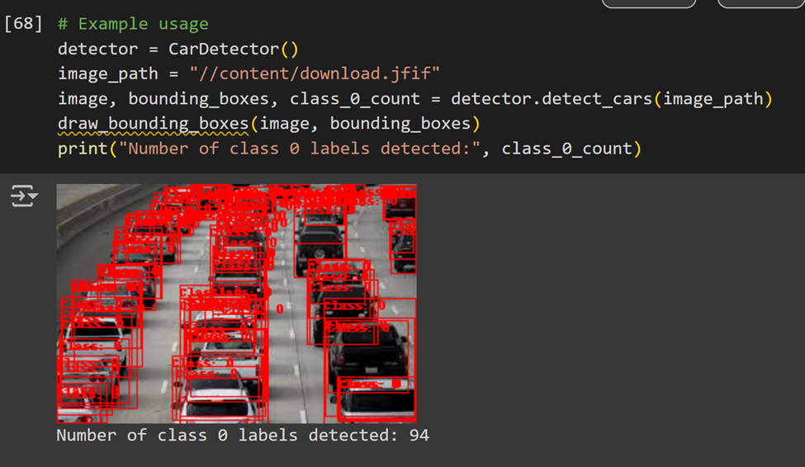

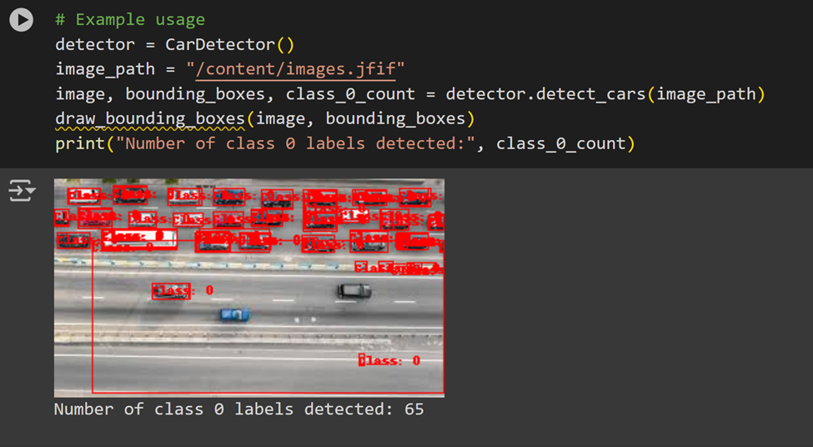

1. Drive_behavior_extra.ipynb



